https://leetcode.com/problems/power-of-three/submissions/2191404533/

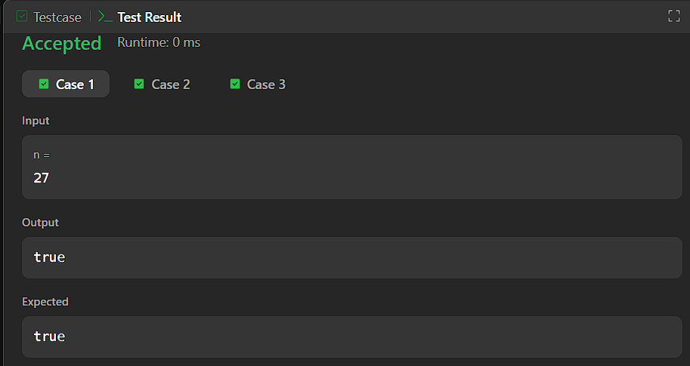


CODE:

bool isPowerOfThree(int n) {
if (n <= 0) {
return false;
}

while (n % 3 == 0) {
n /= 3;
}

return n == 1;
}

